These are only some examples of problems and questions. The midterm exam will not be limited to those types of problems and questions.

The midterm exam will have 2 parts:
Part 1: 21 multiple choice questions + 4 short questions
Part 2: 5 short questions + 5 problem solving questions

### Chapter 2, P23. Give a sketch of how an operating system that can disable interrupts could implement semaphores

To do a semaphore operation, the operating system first disables interrupts.
Then it reads the value of the semaphore. If it is doing a down and the semaphore
is equal to zero, it puts the calling process on a list of blocked processes
associated with the semaphore. If it is doing an up, it must check to see if any
processes are blocked on the semaphore. If one or more processes are
blocked, one of then is removed from the list of blocked processes and made
runnable. When all these operations down or up have been completed, interrupts can be
enabled again.

disable interrupts
down(s):
if (s>0)
s--;
else
put the calling process to sleep in Queue(s) /* until somebody else does “up(s) */
unable interrupts

disable interrupts
up(s):
if (s == 0) and (Queue(s) is not empty)
wakeup a process and remove it from Queue(s);
else
s++;
unable interrupts

### Check if a state is safe? Show all steps.
Can you use Petri nets to prove it? If yes show it.

### Ex1. Chapter 3 Problem 20 p.187:
A system has four processes and five allocable resources. The current allocation and maximum needs are as follows:
Allocated Maximum Available
Process A 10211 11211 00111
Process B 20110 22210
Process C 11010 21310
Process D 11110 11221

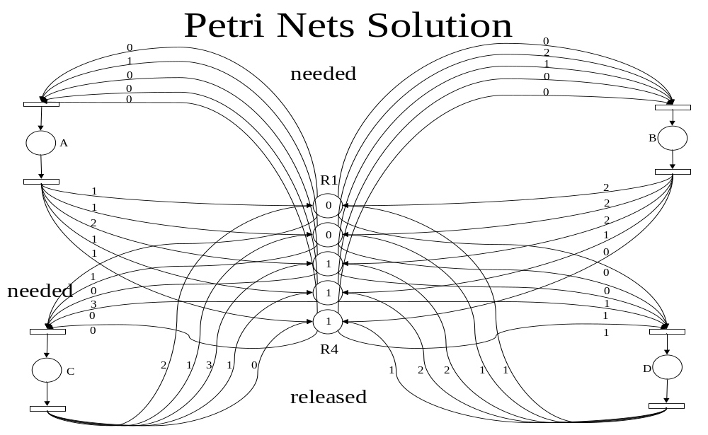
1. Process D takes 00111 making it 11221
2. Process D finishes and releases its resources making the available = 1221
3. Process A takes 01000 making it 11211
4. Process A finishes and releases its resources making the available = 1432
5. Process C takes 10300 making it 21310
6. Process C finishes and releases its recourses making the available = 32442
7. Process B takes 02100 making it 22210
8. Process B finishes and releases its recourses ending all processes.

### Ex2. P4 request (0 0 1 0)

CONDITION AT REQUEST:
Assigned = Needed =
P0 = (3 0 1 1) P0 = (1 1 0 0)
P1 = (0 1 1 0) P1 = (0 1 0 2)
P2 = (1 1 1 0) P2 = (3 1 0 0)
P3 = (1 1 0 1) P3 = (0 0 1 0)
P4 = (0 0 0 0) P4 = (2 1 1 0)
E = (6 3 4 2)
P = (5 3 3 2)
A= (1 0 1 0)

TEST THE REQUEST CONDITION:
Assigned = Needed =
P0 = (3 0 1 1) P0 = (1 1 0 0)
P1 = (0 1 1 0) P1 = (0 1 0 2)
P2 = (1 1 1 0) P2 = (3 1 0 0)
P3 = (1 1 0 1) P3 = (0 0 1 0)
--> P4 = (0 0 1 0) P4 = (2 1 0 0)
E = (6 3 4 2)
P = (5 3 4 2)
A= (1 0 0 0)

(P0 = (1 1 0 0)) <= (A = (1 0 0 0)) not satisfied
(P1 = (0 1 0 2)) <= (A = (1 0 0 0)) not satisfied
(P2 = (3 1 0 0)) <= (A = (1 0 0 0)) not satisfied
(P3 = (0 0 1 0)) <= (A = (1 0 0 0)) not satisfied
(P4 = (2 1 0 0)) <= (A = (1 0 0 0)) not satisfied

This is an unsafe state. DO NOT give P4 (0 0 1 0) resources.

### Chapter 3, Problem22 p.187.
The only answer is that we must let one of the processes finished 1st, and then starts another process. If both processes A and B start with different request, it will result that both processes hold one of the resources and never going to release until the process finished, which will result the deadlock.
So for all the answers of deadlock free, A and B must start with same request. The answers are:
A(1,2,3), B(1,2,3)
A(1,2,3), B(1,3,2)
A(1,3,2), B(1,2,3)
A(1,3,2), B(1,3,2)
A(2,1,3), B(2,1,3)
A(2,1,3), B(2,3,1)
A(2,3,1), B(2,1,3)
A(2,3,1), B(2,3,1)
A(3,1,2), B(3,1,2)
A(3,1,2), B(3,2,1)
A(3,2,1), B(3,1,2)
A(3,2,1), B(3,2,1)

So 12 / 36 = 1/3 of all combinations are deadlock free

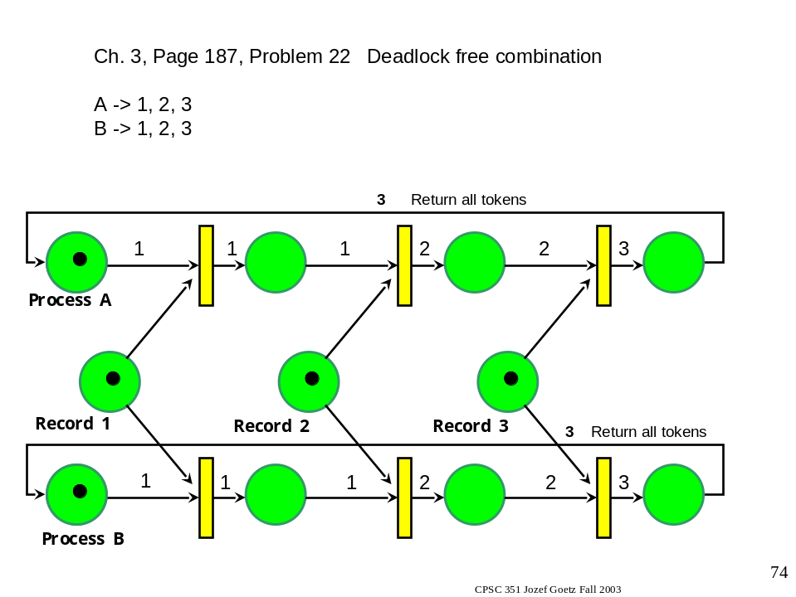

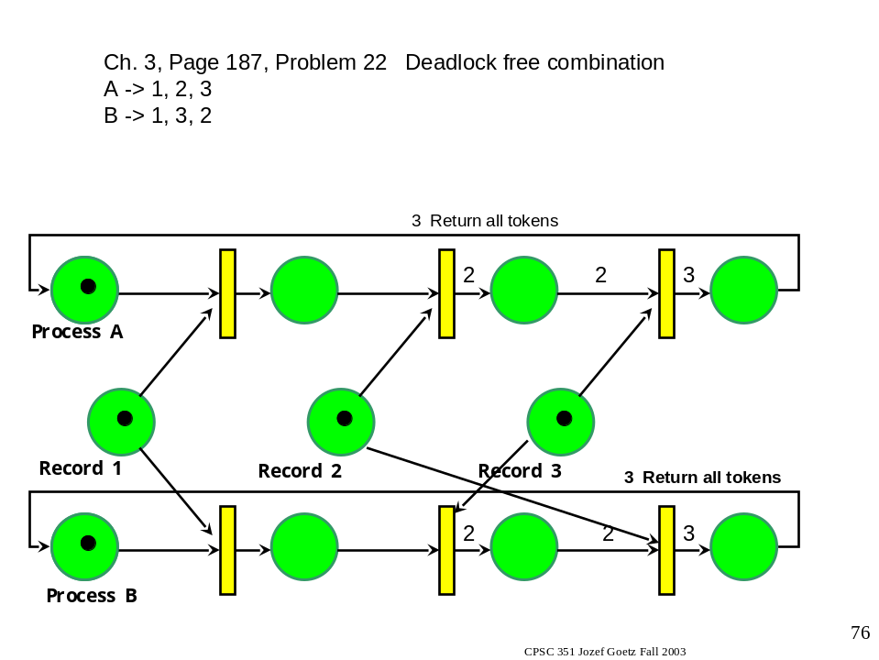

### _____ A preemptive version of shortest job first is
A) shortest remaining time next, B) three-level scheduling, C) first-come first served, D) round-robin scheduling, E) none of these.

### In what two places may threads be implemented?

in the kernel
in user space pg 90,93

### Requiring a process to request resources in a pre-specified order is for the purpose of avoiding
A) two-phased locking, B) mutual exclusion, C) preemption, D) circular wait pg 182, E) none of these

###. _____ Nearly all UNIX systems support a windowing system called
A) Windows NT, B) GUI, C) X Windows, D) Linux, E) none of these

###. _____ What is the technique which is used to allow a computer to run a process requiring more memory than the computer has?
A) Interprocess communication, B) BIOS, C) Deadlock avoidance, D) virtual memory, E) none of these

###. List the three steps of interrupt processing
A)
B)
C)
taking the interrupt,
running the interrupt handler,
returning to the user program pg 30

###. Resource management includes multiplexing or sharing of resources in time and ____space____pg5________

###. Name three types of events for which an event driven program typically waits.
A)
B)
C)
key strokes, mouse moved, mouse button clicked,
insert floppy disk pg 53

###. Name three special registers used by CPUs
A)
B)
C)
Pg27

###. Describe the use of the base and limit registers when a program is loaded into memory and begins running

base register set to where in memory program is loaded
limit register set to size of program and text
any memory reference generated is added to the base register
memory reference generated must be smaller than limit register
if memory reference goes outsides bounds specified by these two registers, OS halts the program pg 26,7

###. A hard drive is rotating at 7200 rpm. There are 16 sectors per track. Each sector has 512 bytes. Seek time is an average of 8 msec and moving from one track to the next takes 1 msec. What is the worst case time to read a file of 750Kb which is
stored on contiguous tracks (1 Kb = 1024 bytes)?

750*1024 = 768000 bytes 768000/512 = 1500 sectors
1500/16 = 5.85938 tracks (read from 6 tracks)
1 revolution = 60/7200 = .00833 sec = 8.33msec
8 msec initial seek + 5 * 1 msec track change time +
5.85938 * 8.333msec read time = 61.862msec

###. _____ No two processes may be simultaneously inside
A) the print spooler, B) memory, C) their critical region, D) the interrupt vector,E) none of these
###. _____ A preemptive version of shortest job first is
A) shortest remaining time next, B) three-level scheduling, C) first-come first served, D) round-robin scheduling, E) none of these.

###. Describe the differences between a preemptive and a nonpreemptive scheduling algorithm.
Preemptive:
picks a process, lets it run for maximum of some fixed time
if still running at end of interval, it is suspended
another process chosen to run
clock interrupt required to give control back to scheduler
NON preemptive:
scheduler picks a process, lets it run until it blocks
(blocks waiting or I/O or for another process)
or until it voluntarily releases CPU
no scheduling decisions made during clock interrupts,
process running before clock interrupt resumes afterwards
pg 135

###. Name four proposals for achieving mutual exclusion.
disabling interrupts
lock variables
strict alteration
Peterson's solution
Test and Set Lock hardware instruction pg 103 - 107

###. _____ When the state of a process is written to a file so that if necessary it can be restarted at that point some other time, this is called
A) deadlock avoidance, B) the banker's algorithm, C) check pointing, D) the ostrich algorithm, E) none of these

###. Describe how the competition for disk space for spooling could lead to deadlock.
two processes each fill up half the available spooling space
neither is finished producing output
the printing daemon does not start printing until all output is generated
there is no room to do so, deadlock results

###. Two processes, P1 and P2, both require resources A and B. Write a sequence of events which would result in deadlock.

P1 asks for and receives resource A
P2 asks for and receives resource B
P1 asks for resource B, not available, put in wait mode
P2 asks for resource A, not available, put in wait mode
both P1 and P2 in wait mode for something that will never occcur
deadlock pg 162

Short questions:

Name only the basic hardware elements for each computer generation.

Name the basic software concepts introduced for each computer generations.

Name four OS features needed for multiprogramming.

Name four advantages of the distributed systems.

Name four main reasons for having threads with a very short description.

Name five advantages of implementing threads.

How do we avoid race conditions?

Show the solution in C++ or Java or Petri nets for the Producer – Consumer problem with message passing.

